Academic Year 2021 – 2022

Science Department Curriculum

Remote Learning Plan – Schemes of Learning Overview

KS4 Science
Students will follow the sequence of the online textbook from AQA answering questions as they go. Each lesson they will be assigned a task for the pages used from that lesson.
Kerboodle:

- In the search bar type in www.kerboodle.com

Username: your first initial and second name i.e Dave Smith = dsmith
Password – default password = your usename i.e dsmith but then after logging in you can change your password.
Institute code- dj0
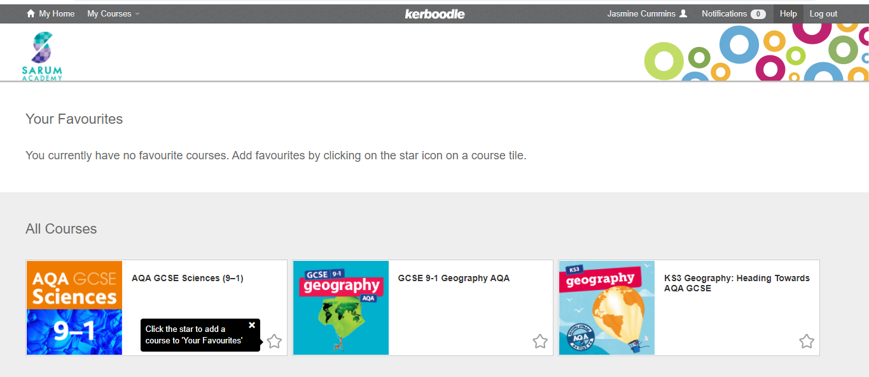
- Select the course you are doing [AQA GCSE Sciences (9-1)]
- Select digital book

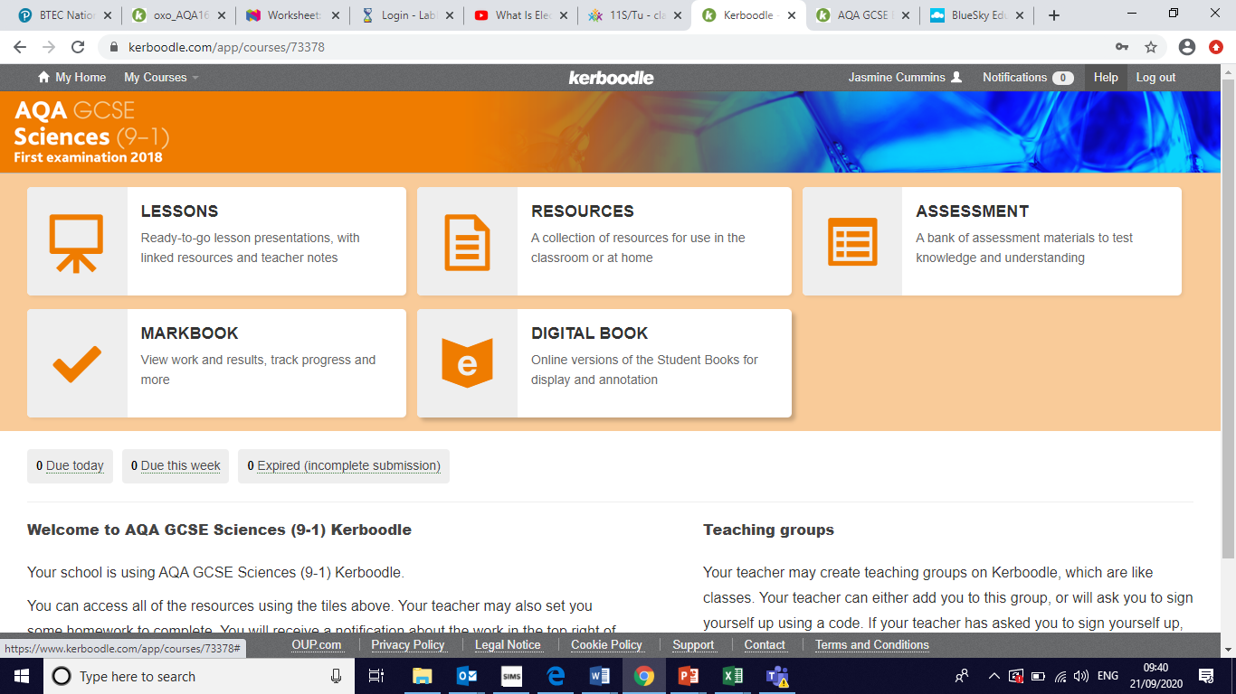

- Select the following books
- Biology Combined Sciences text book: Trilogy
or
Physics Combined Sciences text book: Trilogy
Or
Chemistry Combined Sciences text book: Trilogy

BBC Bitesize for KS4 Science has been linked. Oak National Academy has also been linked, which has video lessons and assessments for reviewing student knowledge.
On the 4 lesson of each week students will be given a topic on Tassomai to complete with a minimum of 25 questions and 55% correct answers target.
Year 9:
Term | Unit | Core Content | Links
1 | Biology: CELL BIOLOGY | Eukaryotes, prokaryotes, cell structure, microscopy, cell specialisation, mitosis, chromosomes, diffusion, osmosis, active transport | Textbook Biology for combined science P4-35  https://classroom.thenational.academy/units/cell-biology-b859  https://www.bbc.co.uk/bitesize/topics/z2mttv4
 | Chemistry: ATOMIC STRUCTURE | Atoms, atomic number, mass number, electron structure, ions, metals and non-metals, history of the Periodic Table, separation techniques | Textbook Chemistry for combined science P2-33  https://classroom.thenational.academy/units/atomic-structure-and-periodic-table-c831  https://www.bbc.co.uk/bitesize/topics/zcckk2p
2 | Chemistry: QUANTITATIVE CHEMISTRY | Relative formula mass, conservation of mass, thermal decomposition, the mole, balancing equations | Textbook Chemistry for combined science 56-65  https://classroom.thenational.academy/units/quantitative-chemistry-4db7  https://www.bbc.co.uk/bitesize/topics/zsnyy4j
 | Physics: ENERGY | Energy stores and transfers, work done, power, specific heat capacity, insulation, efficiency, energy sources | Textbook Physics for combined science 2-43  https://classroom.thenational.academy/units/energy-c750  https://www.bbc.co.uk/bitesize/topics/z89ddxs
3 | Physics: PARTICLE MODEL | Density, particles, internal energy, changes of state, specific heat capacity, Brownian motion | Textbook Physics for combined science P70-95  https://classroom.thenational.academy/units/particle-model-of-matter-a6d5  https://www.bbc.co.uk/bitesize/topics/z3ybb82
 | Biology: ORGANISATION | Cell organisation, digestion, enzymes, food tests, the lungs, circulatory system, blood, cardiovascular system, cancer, plant transportation | Textbook Biology for combined science P36-66  https://classroom.thenational.academy/units/organisation-2345  https://www.bbc.co.uk/bitesize/topics/zwj22nb
4 | Biology: BIOENERGETICS | Aerobic respiration, anaerobic respiration, metabolism, photosynthesis, limiting factors | Text book Biology for combined science 112-131  https://classroom.thenational.academy/units/bioenergetics-244e  https://www.bbc.co.uk/bitesize/topics/zgr997h
 | Chemistry: BONDING | States of matter, metal and non-metal reactions, metallic bonding, ionic bonding, covalent bonding, giant covalent structures, allotropes of carbon, polymers | Textbook Chemistry for combined science 34-55  https://classroom.thenational.academy/units/bonding-structure-and-the-properties-of-matter-e93f  https://www.bbc.co.uk/bitesize/topics/z33rrwx
5 & 6 | Chemistry: ENERGY CHANGES | Energy stores, exothermic reactions, endothermic reactions, reaction profiles | Textbook Chemistry for combined science 96-105  https://classroom.thenational.academy/units/energy-changes-b607  https://www.bbc.co.uk/bitesize/topics/z27xxfr
 | KS4 Assessment Week | Assessment on all Units covered in year 9 so far
 | Biology: INFECTION & RESPONSE | Communicable disease, bacterial disease, viral disease, fungal disease, protist disease, human defence systems, fighting disease, vaccinations, drug development | Text book Biology for combined science P72-111  https://classroom.thenational.academy/units/infection-and-response-4f71  https://www.bbc.co.uk/bitesize/topics/z9kww6f

