Academic Year 2021 – 2022

Science Department Curriculum

Remote Learning Plan – Schemes of Learning Overview

KS4 Science
Students will follow the sequence of the online textbook from AQA answering questions as they go. Each lesson they will be assigned a task for the pages used from that lesson.
Kerboodle:

- In the search bar type in www.kerboodle.com

Username: your first initial and second name i.e Dave Smith = dsmith
Password – default password = your usename i.e dsmith but then after logging in you can change your password.
Institute code- dj0
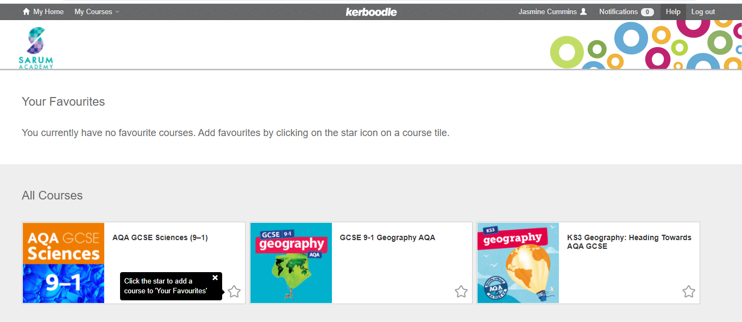
- Select the course you are doing [AQA GCSE Sciences (9-1)]
- Select digital book

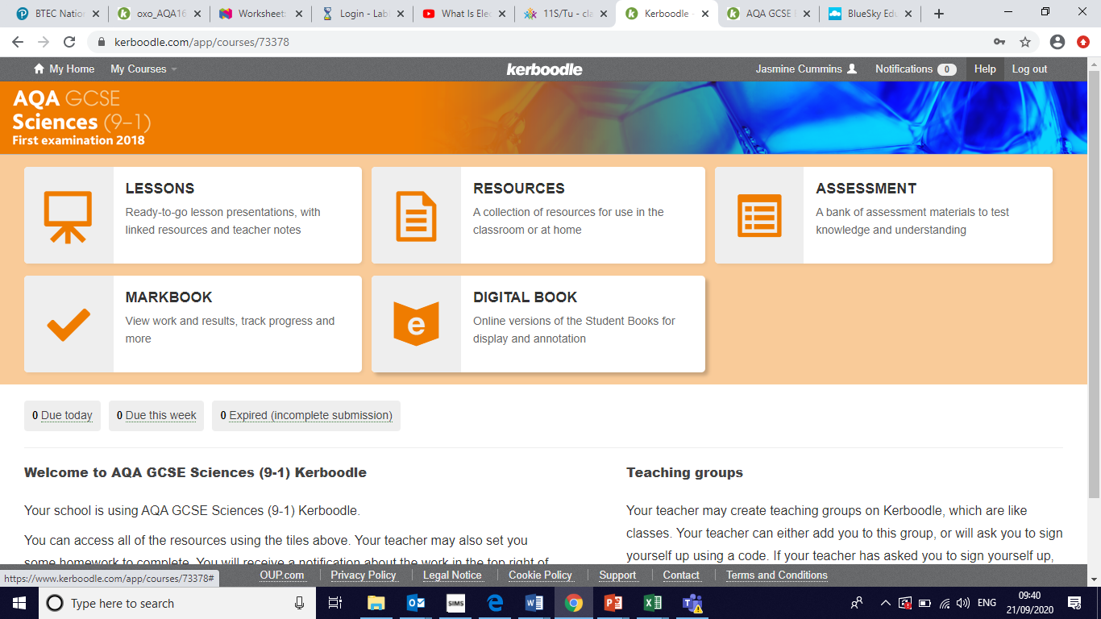

- Select the following books
- Biology Combined Sciences text book: Trilogy
or
Physics Combined Sciences text book: Trilogy
Or
Chemistry Combined Sciences text book: Trilogy

BBC Bitesize for KS4 Science has been linked. Oak National Academy has also been linked, which has video lessons and assessments for reviewing student knowledge.
On the 4 lesson of each week students will be given a topic on Tassomai to complete with a minimum of 25 questions and 55% correct answers target.
Year 10:
Term | Unit | Core Content | Links
1 | Chemistry: QUANTITATIVE CHEMISTRY | Relative formula mass, conservation of mass, thermal decomposition, the mole, balancing equations | Textbook Chemistry for combined science 56-65  https://classroom.thenational.academy/units/quantitative-chemistry-4db7  https://www.bbc.co.uk/bitesize/topics/zsnyy4j
 | Physics: PARTICLE MODEL | Density, particles, internal energy, changes of state, specific heat capacity, Brownian motion | Textbook Physics for combined science P70-95  https://classroom.thenational.academy/units/particle-model-of-matter-a6d5  https://www.bbc.co.uk/bitesize/topics/z3ybb82
2 | Biology: BIOENERGETICS | Aerobic respiration, anaerobic respiration, metabolism, photosynthesis, limiting factors | Text book Biology for combined science 112-131  https://classroom.thenational.academy/units/bioenergetics-244e  https://www.bbc.co.uk/bitesize/topics/zgr997h
 | Chemistry: ENERGY CHANGES | Energy stores, exothermic reactions, endothermic reactions, reaction profiles | Textbook Chemistry for combined science 96-105  https://classroom.thenational.academy/units/energy-changes-b607  https://www.bbc.co.uk/bitesize/topics/z27xxfr
3 | Physics: RADIATION | Isotopes, nucleus, types of radiation, radioactive decay, half-life, irradiation, contamination, nuclear fission | Textbook Physics for combined science P44-69  https://classroom.thenational.academy/units/atomic-structure-d811  https://www.bbc.co.uk/bitesize/topics/zshssrd
 | Physics: ELECTRICITY | Current, circuit symbols, resistance, potential difference, series, parallel, safety, power, the National Grid | Textbook Physics for combined science P44-69  https://classroom.thenational.academy/units/electricity-f083  https://www.bbc.co.uk/bitesize/topics/zcg44qt
4 | Physics: FORCES | Scalar, vector, contact forces, non-contact forces, weight, mass, gravity, work done, Hooke’s Law, Newton’s Laws, speed, acceleration, distance-time graphs, velocity-time graphs, inertia, braking and stopping distances | Textbook Physics for combined science P96-133  https://classroom.thenational.academy/units/forces-6562  https://www.bbc.co.uk/bitesize/topics/ztmttv4
 | Biology: HOMEOSTASIS & RESPONSE | Homeostasis, nervous system, neurones, reflex arcs, synapses, reaction times, endocrine system, blood glucose, diabetes, menstrual cycle, controlling fertility | Text book Biology for combined science 132-159  https://classroom.thenational.academy/units/homeostasis-and-response-1a15  https://www.bbc.co.uk/bitesize/topics/zyybb82
5 & 6 | Biology: INHERITANCE, VARIATION & EVOLUTION | Sexual reproduction, asexual reproduction, mitosis, meiosis, DNA, inheritance, sex determinism, variation, evolution, extinction, classification | Text book Biology for combined science 160-203  https://classroom.thenational.academy/units/inheritance-variation-and-evolution-0224  https://www.bbc.co.uk/bitesize/topics/zppffcw
 | KS4 Assessment Week | Assessment on all Units covered in year 9 & 10 so far
 | Chemistry: ORGANIC CHEMISTRY | Hydrocarbons, alkanes, alkenes, cracking, fractional distillation | Textbook Chemistry for combined science 128-137  https://classroom.thenational.academy/units/organic-chemistry-7c58  https://www.bbc.co.uk/bitesize/topics/z9488mn

