Core skills – Level 1

Four operations

- Integer addition | A self-marking exercise on addition with increasing levels of difficulty.  “How we do Maths’ video available | https://www.transum.org/software/SW/Starter_of_the_day/students/Basic_Addition.asp?Level=1
- Integer subtraction | A self-marking exercise on subtraction with increasing levels of difficulty.  ““How we do Maths’ video available | https://www.transum.org/software/SW/Starter_of_the_day/students/Basic_Subtraction.asp
- Decimal addition and subtraction | Practise mental and written methods for adding and subtracting decimal numbers.  “How we do Maths’ video available | https://www.transum.org/Maths/Activity/Decimals/Add.asp
- Integer multiplication | A self-marking exercise on multiplication with increasing levels of difficulty.  “How we do Maths’ video available | https://www.transum.org/software/SW/Starter_of_the_day/students/Basic_Multiplication.asp?Level=1
- Division | A self-marking exercise on dividing numbers of up to four digits by one or two-digit whole numbers using the formal written methods of short and long division  “How we do Maths’ video available | https://www.transum.org/software/SW/Starter_of_the_day/students/Basic_Division.asp?Level=1

Fractions

- Equivalence | 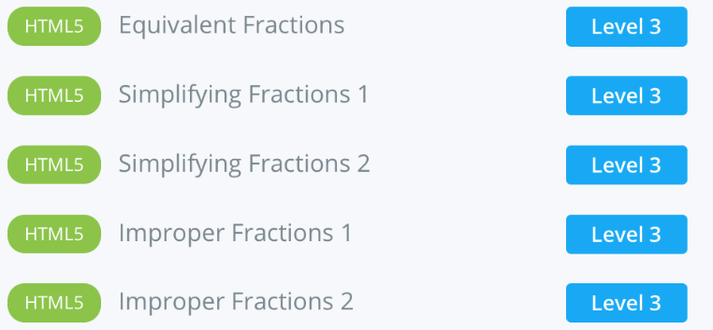 | The following link takes you to the self-marking exercises listed on the left  https://www.mathsworkout.co.uk/number.php  Username: sarum  Password: solid92  Select Number: 16 fractions and the list  “How we do Maths’ video available
- Adding and subtracting, | 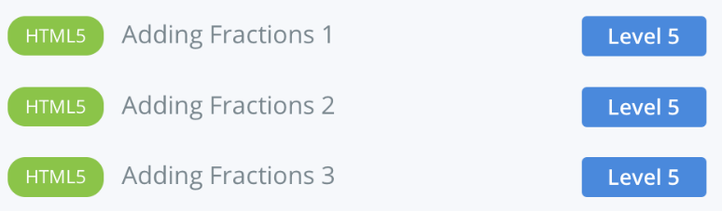
- Multiplying fractions | 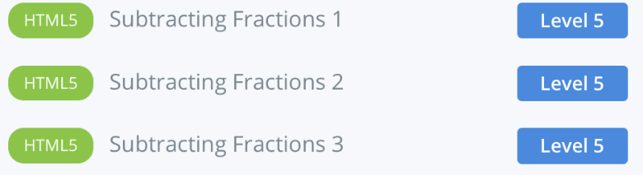
- Multiplying mixed numbers | 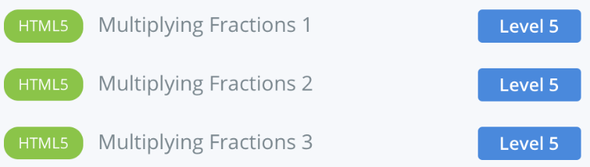
- Dividing fractions | 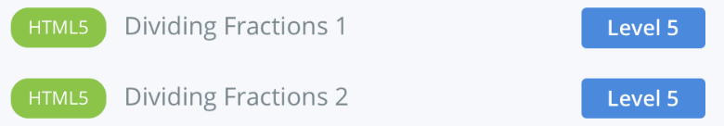

Ratio

Simplify | 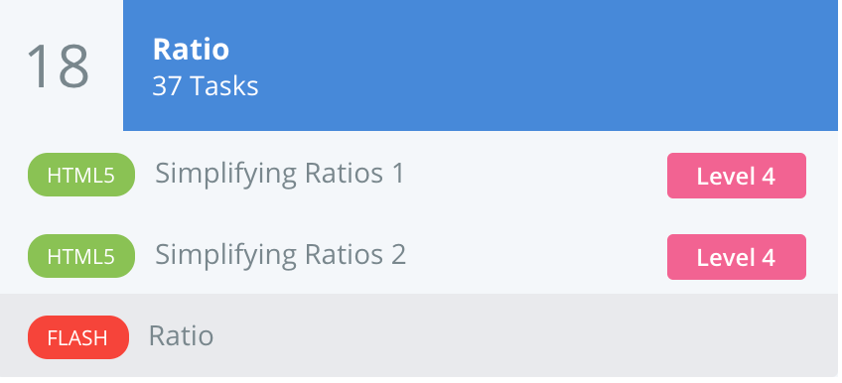 | The following link takes you to the self-marking exercises listed on the left  https://www.mathsworkout.co.uk/number.php  Username: sarum  Password: solid92  Select Number: 18 Ratio  Complete simplifying ratios 1 and 2
Sharing & difference between |  | Go in to Flash ratio and complete target 3 for sharing in to a ratio and then complete the worksheet for next level up  Ratio worksheet – click the document below  “How we do Maths’ video available

Algebra -
Equations

Equations | A series of exercises, in increasing order of difficulty, requiring you to solve linear equations. The exercises are self marking | https://www.transum.org/software/SW/Starter_of_the_day/Students/Equations.asp?Level=1  “How we do Maths’ video available

Averages

Mode, median, mean and range | 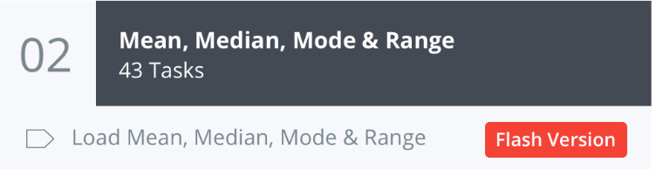 | The following link takes you to the self-marking exercises listed on the left  https://www.mathsworkout.co.uk/number.php  Username: sarum  Password: solid92  Select Statistics and Probability: 02 Mean, Median, mode & range  Follow this link for a song to help you remember the methods for each one  https://www.youtube.com/watch?v=NZpPa1y0Pdk

Area and perimeter

- Perimeter | Self marking questions for perimeter of a rectangle | http://weteachmaths.com/worksheetWizard.html  Shape and space Perimeter of a rectangle
- Composite perimeter | Self marking questions for perimeter of rectilinear composite shapes | https://www.bbc.co.uk/bitesize/guides/zsf39j6/test
- Area | Self-marking questions for area of triangles (by drawing them first) | http://weteachmaths.com/worksheetWizard.html  Shape and space Area of a triangle  The following link takes you to the self-marking questions listed above:  https://mathsworkout.co.uk/geometry.php  Username: sarum  Password: solid 92  Select Geometry: 10- Area
- Composite area | 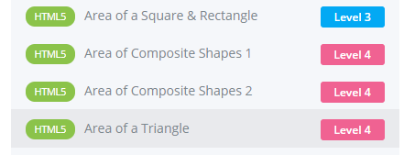

Angles

- Angles on a straight line | 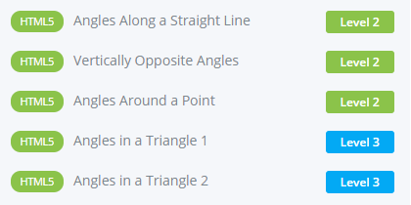 | The link below takes you to self-marked questions on the topics listed to the left:  https://mathsworkout.co.uk/geometry.php  Select Geometry: 07- Angles  Username: sarum  Password: solid92
- Vertically opposite angles
- Angles in triangles
- Angles around a point
- Multistep angles | Use knowledge and reasoning to fill in the missing angles | https://www.transum.org/Maths/Activity/Angle/Chase.asp?Level=2

